**PLANIT Project**

1. **Introduction**

Our project focuses on designing and producing **high-quality daily agendas, planners, and to-do lists** to help individuals **organize their lives and achieve their goals efficiently**. With the growing demand for time management tools, our brand will provide **innovative and customized solutions** that cater to diverse needs, making it the perfect choice for those seeking improved productivity and better organization in their daily lives..

* **Vision**

Providing products that help individuals achieve their goals and organize their lives.

* **Mission**

To become the first choice for customers seeking effective organization and daily inspiration.

1. **Objectives**

* **Brand & Marketing Strategy**

1. Build a strong brand identity with cohesive visual design, clear messaging, and compelling storytelling.

2. Launch a simple online store using low-cost platforms like Shopify or WooCommerce to facilitate direct sales and establish a digital presence.

3. Leverage micro-influencers for promotions through product gifting or commission-based partnerships instead of paid collaborations.

4.Utilize content marketing on Instagram and TikTok with engaging, interactive content to increase brand awareness.

5.Start a free email marketing campaign using platforms like Mailchimp to nurture leads and encourage conversions.

* **Sales & Distribution Strategy**

1. Prioritize online sales first through social media and the e-commerce store to reduce operational costs.
2. Set a gradual sales target, aiming for 20,000 EGP in the first three months, with incremental growth based on demand.
3. Offer customizable agendas at competitive prices to attract university students, small businesses, and personalized gift shoppers.
4. Partner with small stationery shops and bookstores to showcase products in exchange for a revenue share instead of paying for retail space.

* **Product Development & Customer Engagement**

1. Collaborate with emerging local artists at minimal cost or through revenue-sharing agreements to create visually appealing designs.
2. Create free educational content via short Reels and TikTok videos on how to use agendas effectively to boost engagement.
3. Use surveys and interactive posts to gather customer feedback for continuous product improvement.
4. Provide excellent customer service with fast responses on digital platforms to enhance user experience and encourage repeat business.
5. **Grantt Chart**

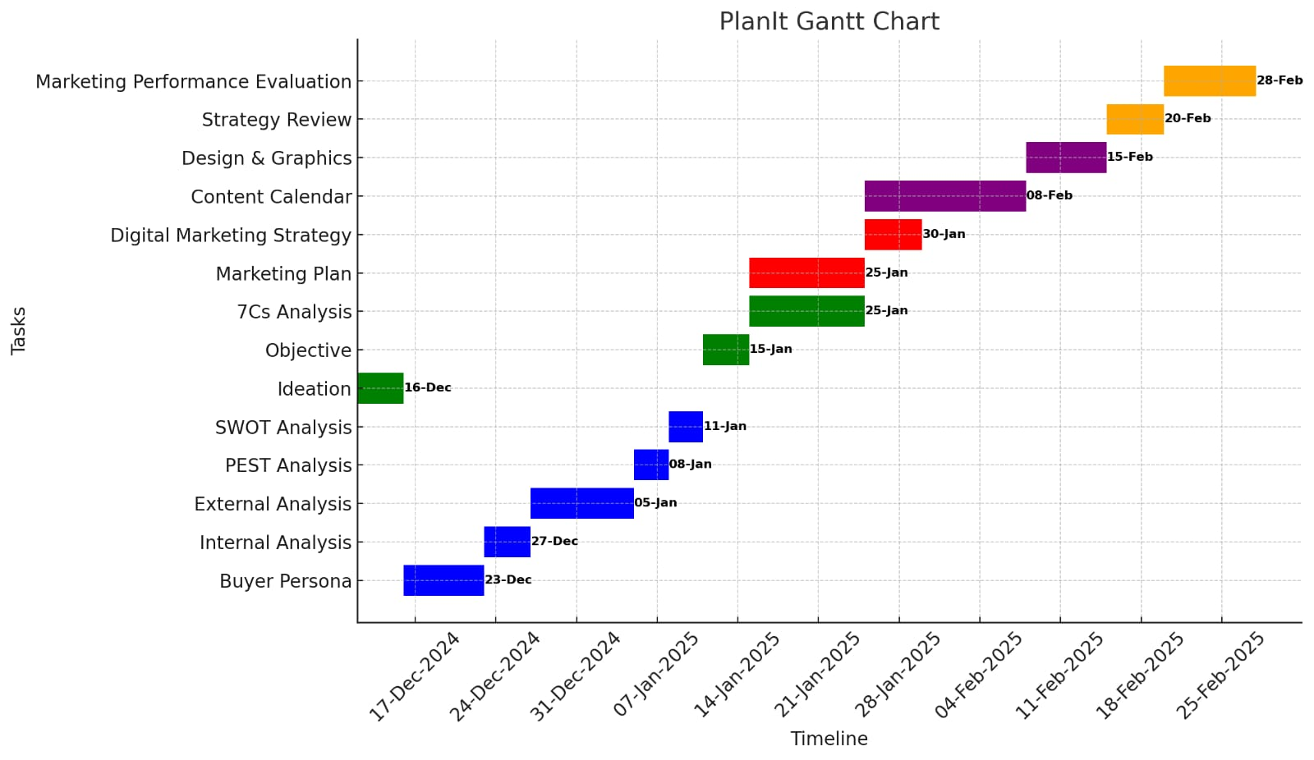

1. **Digital Tools & Platforms for the Strategy**

|  |  |  |
| --- | --- | --- |
| Category | Tool | Usage |
| Market Research & Audience Analysis | Google Forms | Create surveys and collect user insights |
| Google Trends | Identify trending topics |
| Meta Audience Insights | Understand audience demographics |
| Project Management & Team Collaboration | Google Drive / OneDrive | Store and collaborate on files |
| Content Creation & Design | Canva | Design marketing materials |
| ChatGPT | Generate smart marketing content |
| Digital Marketing & Advertising | Meta Ads Manager | Manage Facebook & Instagram ads |
| Google Ads | Run search & display ads |
| Google Analytics | Track website traffic and analytics |
| Mailchimp | Manage email marketing campaigns |
| ChatGPT | Generate AI-powered marketing content |
| Content Scheduling & Publishing | Meta Business Suite | Schedule posts on Facebook & Instagram |
| Planning & Analysis Tools | Excel / Google Sheets | Create planning templates & task lists |
| communication | Whatsapp community |  |
| Telegram |  |
| Google meet |  |

1. **Business canvas model**

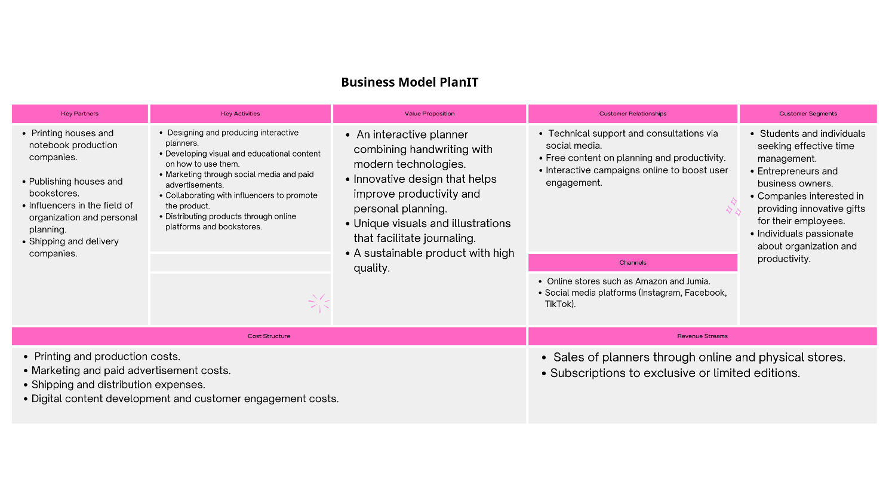

1. **SWOT analysis**

* **Strengths**
* designs, materials and quality
* making customized designs colors layout and paper type
* high quality materials
* creative designs strong marketing and having strong community of customers
* variety in products manufacturing
* Affordable pricing
* Strong Identity: Building a brand identity associated with planning and organization.
* Customization Options: Providing personalized services like adding names or logos to agendas.
* **Weaknesses**
* purchased by limited age range
* quality and creative designs leads to a high production costs .
* narrow target customers as students teachers artists .
* limited audience
* Lack of experience.
* High Competition: A saturated market with many similar brands.
* Dependence on specific seasons like the start of the academic year
* Limited Distribution Channels: If not widely available in stores or online platforms.
* **Opportunities**
* Market Expansion as in Focusing on online sales through e-commerce websites and social media platforms.
* Maintaining a consistent presence on social media platforms and responding to inquiries and messages promptly.
* expanding with more products which increase our target customers
* cooperating with libraries and some stores
* Maintaining a consistent presence on social media platforms and responding to inquiries and messages promptly.
* Offering discounts and promotions.
* Expanding the product range to include stationery, stickers, and other organizing tools.
* **Threats**
* Competitors offering similar products at lower prices
* A growing preference for digital planning apps over paper agendas.
* Inability to price the product competitively and attractively for the market.
* Collaboration with a slow shipping company, leading to customer frustration.
* Economic conditions affecting customers’ purchasing power
* Being a luxury product not essential one
* Lack of funds and capital.

1. **PlanIt Marketing Strategy**

**1. Studying the Latest Digital Marketing Strategies**

We conducted a survey to define the ideal Buyer Persona, allowing us to better understand our target audience’s needs and tailor our content and services accordingly.

We focus on an organic reach strategy instead of paid ads, which helps us build a genuine and engaged audience without relying heavily on advertising budgets.

We implement User-Generated Content (UGC) to increase engagement and build trust in PlanIt through real user experiences.

**2**. **Reviewing Digital Marketing Techniques Used in Successful Projects**

We analyzed the Digital Egypt Report 2024 to identify the most effective digital channels.

Based on market trends, we selected Facebook, Instagram, and TikTok as our primary platforms, as they offer the best engagement rates for the type of content we provide.

Our strategy focuses on a mix of educational, interactive, and high-quality content to attract users and establish PlanIt as a valuable tool

**3. Analyzing Digital Market Trends and Their Impact on Marketing Campaigns**

We used competitor analysis tools to assess their strengths and weaknesses, helping us identify market gaps and develop unique solutions with PlanIt.

1. Our market research highlighted the increasing need for easy-to-use digital planning tools, which led us to focus on providing educational content about efficient planning and task management.

We integrate community engagement elements into our strategy to ensure user loyalty and encourage them to share their experiences with PlanIt.

What sets our strategy apart is our emphasis on high-value content marketing rather than paid promotions, enabling sustainable growth and a loyal user base over time.

1. **Market Research & Data Collection**

To understand the target market for the agenda brand, we will gather data from multiple sources:

**A. Sources of Data Collection**

- Competitor Analysis:

* Studying successful stationery and agenda brands in Egypt (local & online).
* Identifying their pricing, marketing tactics, and customer engagement strategies.

[https://docs.google.com/spreadsheets/d/1FmJa56fzaH5Q9tSGA2tW4eorvGF8eejCgl6Lpl_HOEU/edit? usp=sharing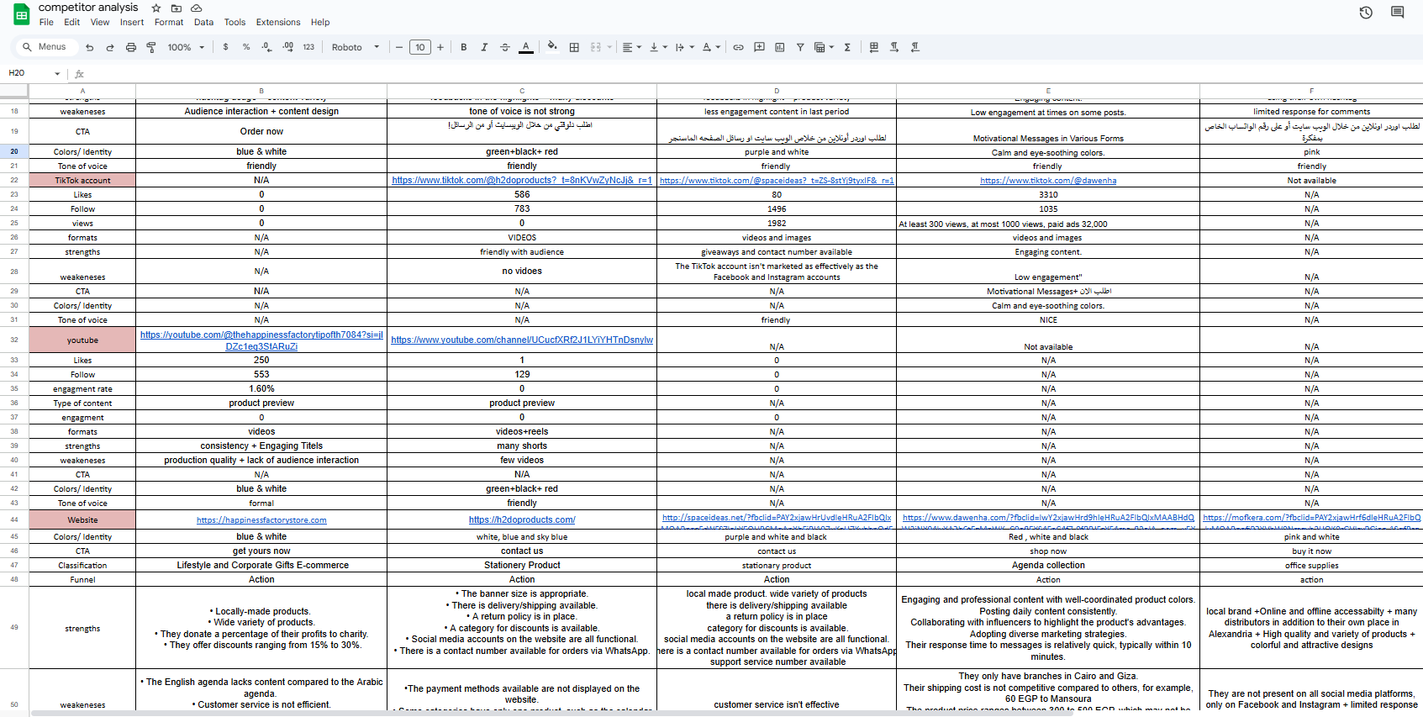](https://docs.google.com/spreadsheets/d/1FmJa56fzaH5Q9tSGA2tW4eorvGF8eejCgl6Lpl_HOEU/edit? usp=sharing)

- Industry Reports & Google Trends:

* Analyzing search trends for agendas and stationery products in Egypt.
* Identifying peak demand seasons (e.g., back-to-school, New Year, Ramadan gift season).

- Social Media Insights:

* Tracking engagement metrics on Instagram, Facebook, and TikTok to identify trends.
* Monitoring customer comments & reviews on competitor pages.

- Online Surveys & Polls:

* Using Google Forms to gather direct feedback from potential customers.
* Create and distribute a Google Forms survey targeting at least 100 potential customers via social media.  
  - Ask key questions like:
* What features do you look for in an agenda?
* What price range do you find reasonable?
* Where do you usually buy planners/stationery?

Survey link : <https://docs.google.com/forms/d/e/1FAIpQLSfYbQ5n7Anx3XXda-XKSJ7zBXBKk37WB8OIaEM9XfKwVhoHSQ/viewform>

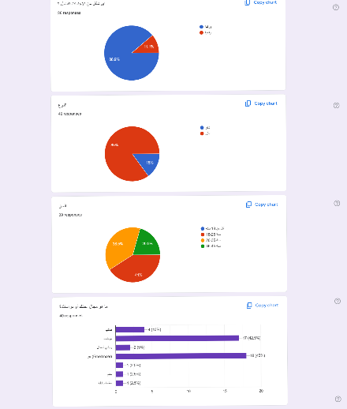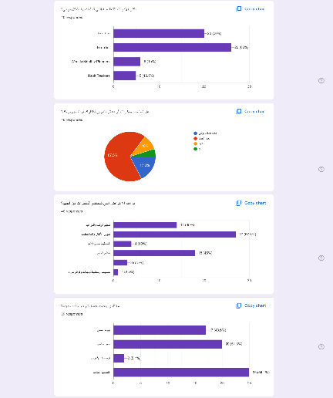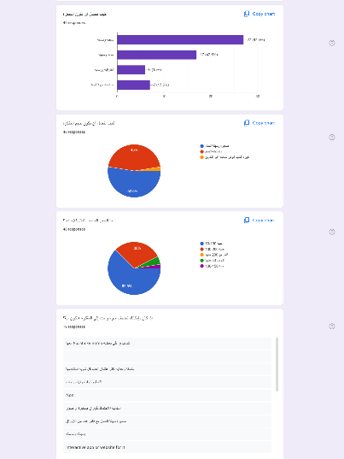

**2. Audience Behavior Analysis on Digital Channels**

To maximize engagement and conversion rates, we will analyze:

- **Instagram , Facebook & TikTok Analytics**

* Identifying what type of agenda-related content performs best (e.g., productivity tips, aesthetic stationery posts).
* Tracking engagement rate, shares, and comments to understand what resonates most.

**3. Creating User Personas**

Based on collected data, we will define key **buyer personas** for targeted marketing:

**Buyer persona 1:Talia Amin**

**- Basic Information:**

* Age: 18 years
* Gender: Female
* Education: High school student
* Work: Not currently employed (full-time student)
* Salary: No fixed income, relies on family support
* Relationship Status: Single
* Living Place: Mansoura, Egypt

**- Interests:**

* Journaling, reading books, and poetry
* Traveling inside and outside Egypt
* Creative self-expression through design and decoration
* Using colorful stationery to personalize her planning process
* Active on social media (TikTok, Instagram, and Facebook)

**- Needs:**

* A structured yet visually appealing agenda to help organize studies and personal life
* A motivational tool that encourages her to achieve her academic goals
* A planner with time management exercises to improve productivity
* Aesthetic and high-quality designs that reflect her personality
* Customization options to make her planner feel unique

**- Behavior:**

* Frequently buys notebooks and stationery with attractive designs
* Engages with influencers and content creators for recommendations
* Follows study tips and productivity hacks on social media
* Prefers affordable but stylish products
* Often forgets small tasks and struggles with time management

**- Barriers to Purchase:**

* May hesitate due to budget constraints as she relies on family support
* Might find it hard to choose if there are too many similar options
* Needs convincing that a planner can actually help improve her organization

**- Marketing Message:***"Stay on top of your studies and express your creativity with a planner made just for you! Organize your academic and personal life in a fun, colorful way, helping you achieve your goals with ease."*

**Buyer Persona: Layla Omar**

- Basic Information:

* Age: 27 years
* Gender: Female
* Education: Studied Architecture
* Work: Freelance Photographer
* Salary: Variable income (project-based earnings)
* Relationship Status: Not mentioned
* Living Place: Alexandria, Egypt

- Interests:

* Social media (Facebook, Instagram)
* Photography and capturing aesthetic visuals
* Loves art and filming vintage and valuable items
* Enjoys traveling and exploring natural landscapes
* Passionate about writing notes and ideas

- Needs:

* A creative and visually appealing planner to organize tasks and ideas
* A structured time management tool to balance work and personal life
* A practical yet elegant agenda that matches her artistic style
* A planner that helps with goal setting and creative brainstorming

- Behavior:

* Frequently takes notes and highlights key ideas during work
* Seeks stylish and high-quality products that align with her taste
* Prefers simple, functional designs with artistic appeal
* Uses to-do lists and activity books for better time management

- Barriers to Purchase:

* Needs motivation to stay on track with her goals
* Struggles with balancing personal life and professional commitments
* Requires a planner that is both stylish and functional

- Ideal Agenda Features:

* High-quality and stylish design that matches her artistic personality
* Colorful bookmarks, to-do lists, and activity pages for creative engagement
* Elegant and practical layout for organizing work, ideas, and daily life
* Durable packaging to keep the product safe

- Marketing Message:  
*"Transform your creativity into action! Organize your thoughts, balance your work-life, and capture inspiration with a planner designed for artistic minds like yours."*

1. **Digital Marketing Strategy**
   1. **Marketing Channels Selection**

- **Instagram** Posting images and videos showcasing planner and notebook designs Using Stories and Reels to increase engagement

- **TikTok** Creating short videos on how to use planners and organize time effectively

- **Facebook** Setting up a brand page to share educational and promotional content

* 1. **Advertising Campaign**

- Campaign Goal Increase brand awareness and boost sales

- Target Audience Students young professionals and anyone interested in time management and journaling

* **Ad Types**

- Instagram and Facebook Ads Images and videos showcasing planner designs

- TikTok Ads Short videos demonstrating how to use planners and productivity tips

* **Special Offers**

- Buy a planner and get a free notebook

- 20 percent discount for the first 3 orders

* **Search Engine Optimization SEO**

- Keyword Targeting Using relevant keywords to ensure visibility when searching for Daily Planner or Time Management Notebook

- Optimized Bio and Hashtags Writing targeted keywords in social media bios and using popular hashtags for better reach

* 1. **Marketing content plan**

[**https://docs.google.com/spreadsheets/d/1_QkdFLv9TnsvHGeHYo3ziewZRgIVHbZLWNqU42Of10Y/edit?usp=sharing**](https://docs.google.com/spreadsheets/d/1_QkdFLv9TnsvHGeHYo3ziewZRgIVHbZLWNqU42Of10Y/edit?usp=sharing)

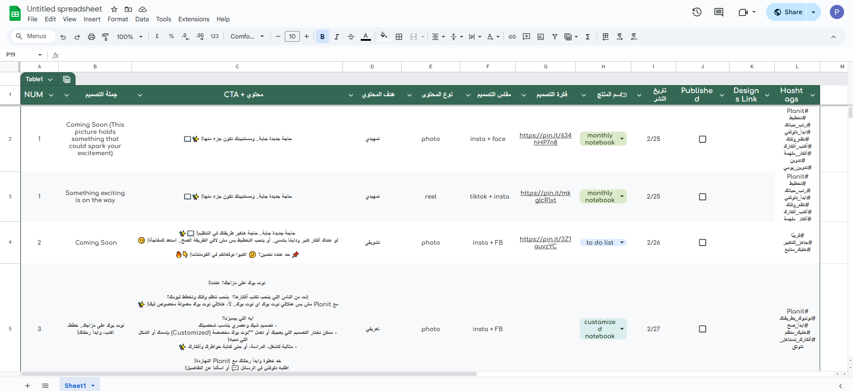

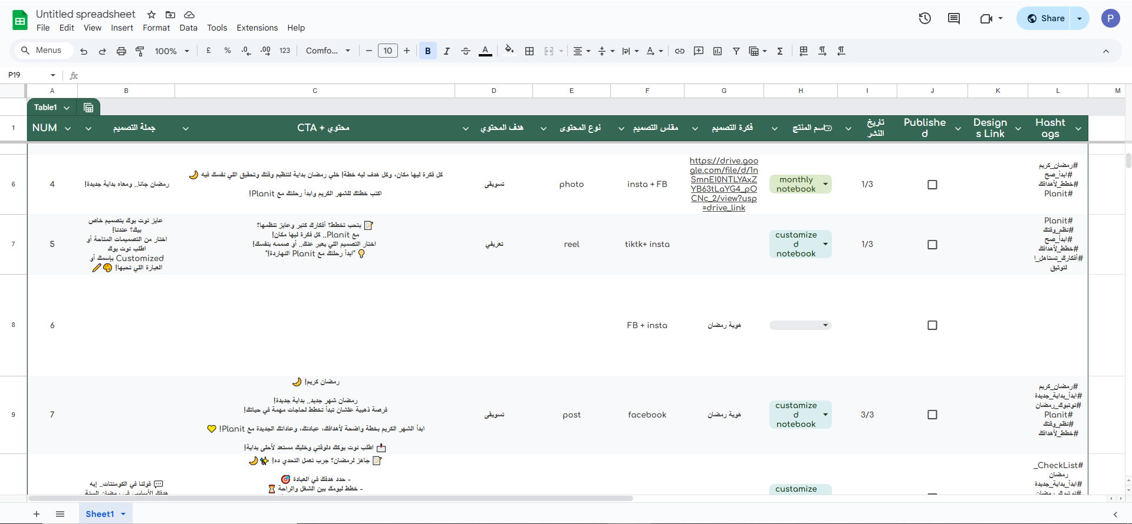

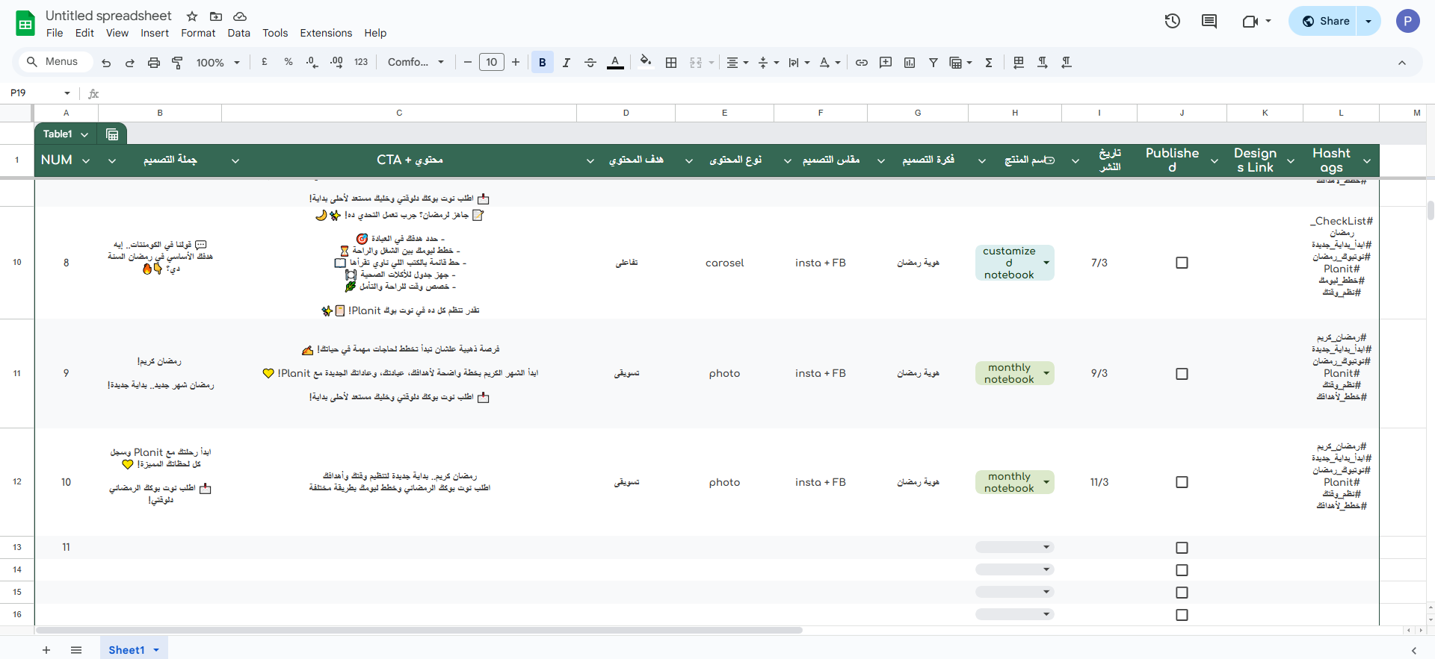

* 1. **Key Performance Indicators KPIs**
* **Reach Number** of people who saw the campaign content The goal is to maximize reach and ensure the campaign reaches a broad audience of potential customers
* **Engagement Rate** Number of likes comments and shares The goal is to increase social media engagement from 5 percent to 8 percent within one month
* **Conversions** Number of people who made a purchase or signed up due to the campaign The goal is to increase the total number of orders from 50 to 100 within two months
* **Customer Acquisition Cost CAC** Cost of acquiring a new customer through the campaign The goal is to optimize ad spending and ensure an effective cost per acquisition under budget constraints
* **Click Through Rate CTR** Number of clicks on links in the Bio or Stories The goal is to increase the CTR from 3 percent to 5 percent within one month
* **New Followers Growth** in Instagram followers The goal is to increase Instagram followers from 1000 to 1500 within two months
* **Return on Investment ROI** Profitability of the campaign The goal is to achieve a 20 percent ROI within two months
* Results Analysis and Performance Optimization
* Review KPIs Analyzing data to identify strengths and areas for improvement
* Adjust Strategy Making necessary changes to improve performance and achieve campaign goals

This strategy ensures effective marketing efforts to boost brand growth and sales Let me know if you need any adjustments